Update 26-5-2017

It appears as though prolonging the Ca2+ transient DOES affect the amplitude of the twitch in cardiac muscle. Thus, in order to insert isometric Calcium into the work-loop model, this needs to be taken into account. Perhaps the Y-axis on the Force vs. SL figures should be %maximum force?

A more appropriate course of action could be to shift the focus of the paper from exploring the effect of Ca2+ and velocity dependence on ES curves to understanding how Ca2+ can account for the entire difference between isometric and WL ES curves. I need to understand what mechanisms are involved in the relationship between Ca2+ transients and the amplitude of isometric force twitches.

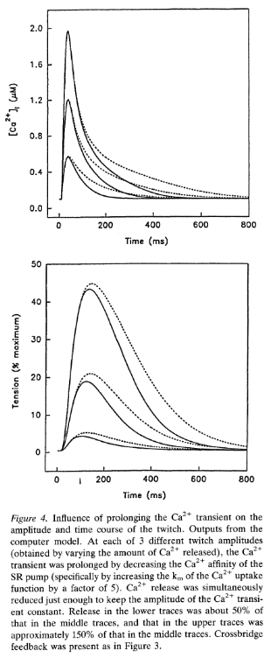

This figure comes from The book Molecular Physiology and Pharmacology of Cardiac Ion Channels and Transporters Chapter 43 *Evaluation of changes in myofibrillar Ca2+ sensitivity in intact cardiac cells* John R. Blinks and James D. Hannon

This shows that prolonging the Ca2+ transient influences the peak twitch force.

The above figure comes from model simulations (and I am not sure of the model parameters such as SL, TmpC, species, etc…); therefore, I would like to see if I can find experimental data that support this phenomenon.

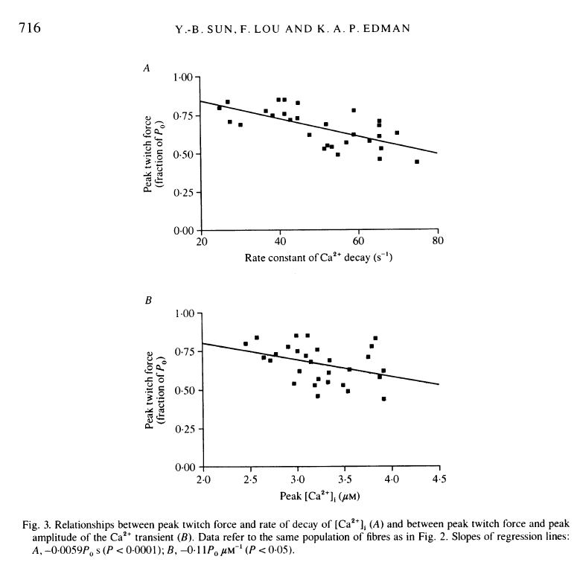

The above figure shows that in frog skeletal muscle fibres, a slower decay of the Ca2+ transient was associated with a greater amplitude of the isometric twitch. This is certainly helpful; however, I would like to see some evidence from cardiac muscle.

Something I have learned by looking at the Editorial “Regulation of Myocardial Contractility by a Downstream Mechanism” 🡪 In the model simulations I am running, I am looking at “Upstream Mechanisms”? (I think?). This is because I am inserting fixed calcium transients into either an isometric contraction or a work-loop contraction. In other words, the model mechanisms remain unchanged. What IS changing is the “shape” of the intracellular Ca2+ transient, i.e. how much calcium is present in the intracellular space at a given time during the contraction. We want to know, specifically, how, and by what mechanisms, the width of the Ca2+ transient affects tension development. What we are not looking at is downstream mechanisms, i.e “an alteration of the response of the myofilaments to a given level of occupancy of Ca2+ binding sites on troponin-C. The distribution of mechanisms into the downstream, upstream, and central categories comes from Binks “Analysis of the effects of drugs on myofibrillar Ca2+ sensitivity in intact cardiac muscle. In: Modulation of Cardiac Calcium Sensitivity…”

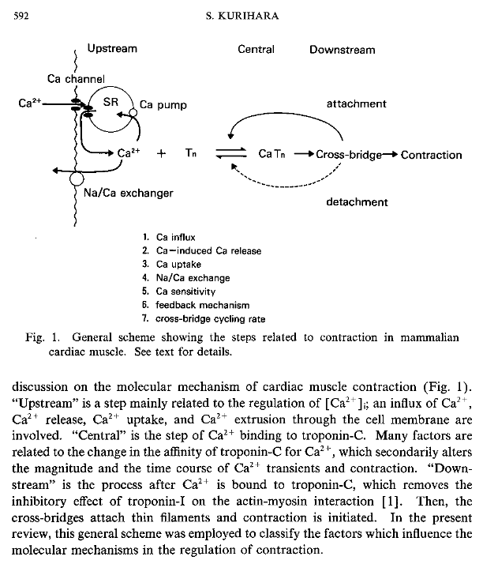

NOTE: This image comes from Kurihara’s Mini Review titled “Regulation of Cardiac Muscle Contraction by Intracellular Ca2+”

\*\*I was looking at this editorial in the first place because it had some great citations, including:

Blinks “Modification of myofibrillar responsiveness to Ca as an inotropic mechanism”

Kurihara’s Mini Review titled “Regulation of Cardiac Muscle Contraction by Intracellular Ca2+”

* this is a great article for getting my head around the different chemicals and things that physiologists use to perform such precise experiments. When it comes to analysing upstream mechanisms involved in the [Ca2+]i / force relationship the following information is known:
  + Ryanodine can lock the Ca2+ release channels of the s.r. in an open state. “Peak Ca2+ signal in twitch contraction is decreased, tension is significantly diminished, Prolonged time course of Ca2+ transient and tension
  + Caffeine: releases Ca2+ from the s.r. by enhancing the Ca-induced-Ca release mechanism. Prolongs the time course of the Ca2+ transient (this is thought to be due to the slower Ca2+ uptake by the s.r. but mechanism not fully understood). \*\* An increase in the apparent Ca2+ sensitivity should prolong the relaxation time and shorten the decay time of Ca2+ transients. However, the slower uptake of the Ca2+ by the s.r. probably masks the shortening of the decay of Ca2+ transients.
  + Thapsigargin is known as a specific inhibitor of the Ca2+ pump in the s.r.
    - applying Thapsigargin results in the time course of cell length shortening and Ca2+ signal to be prolonged (slower decay time) and peaks decerased.
    - In contrast to single isolated myocytes, Thapsigargin does not alter the magnitude or the time course of tension in papillary muscles
  + Ca2+ overload: when [Ca2+]i increases over the Ca2+ uptake capacity of the s.r., oscillation of the Ca2+ signal occurs. This oscillation is caused by the spontaneous Ca2+ release from the s.r.

Monday 29-5-2017: the plan of action will be to look over the Kurihara paper a bit closer, looks at the citations from this paper.

to do:

* have you searched upstream mechanisms that influence peak force in cardiac muscle fibres?